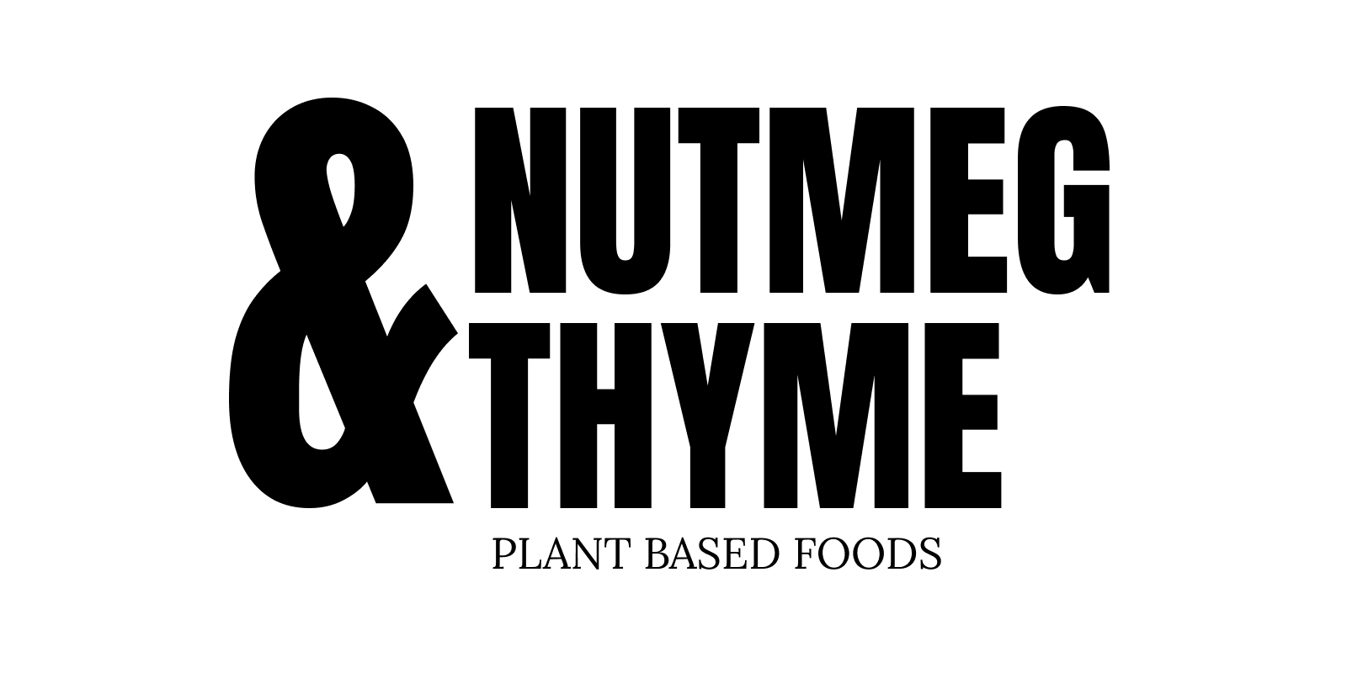
100% Gluten, Dairy, Wheat, Egg Free Kitchen
We revolve our menus around seasonal and local produce, all our food is prepared fresh in the cafe by Grace and Emily.

ARTISAN SANDWICHES
made fresh with our focaccia and local organic leaves
£8.50

Fig Chutney, Pesto & Camembert (cashew)

Garlic roasted Artichokes, Whipped Butterbean, Leek & Tahini (sesame)

Roasted Oyster Mushroom & Smashed Pea pesto

HOT BOWLS £8
served with our focaccia or a side salad selection £11
(our Hot bowls change regularly, some favourites include):

- Aubergine Sicilian Style Stew

- Squash & Coconut Dal

- Celeriac Hazelnut Butter Soup

- Thai Spiced Root & Coconut Soup

- Oyster Mushroom Ragu

- Harissa Caraway Aubergine Stew

BRUNCH DISHES £12

Root Veg Rostis
or
Thai Spiced Sweetcorn Fritters
with Pea Basil Guacamole and a selection of seasonal salads

SEASONAL SALAD SELECTION
£7 side
£10 main
(our selection changes regularly, including)

Green Bean Hazelnut Orange
Celeriac, Pecan, Parsley
Carrots, Black Rice, Basil
Tahini Slaw
Roasted Chipotle Pineapple Salsa
Black Chickpeas, Roasted Roots
Turmeric Cauliflower, Almond Romesco

OUR BAKES & TREATS SELECTION
includes…

Gingerbread Passionfruit Cake (maize)
Chocolate Fudge Cake (maize)
Tahini Almond Cookies (sesame, nuts)
Rosemary Hazelnut millionaires Shortbread (nuts, gf oats)

Squash / Tomato / Celeriac Tarte Tatin (soy, maize)
Focaccias - Squash & Sage, Olives & Rosemary (yeast, maize)
Millet Bread (yeast)
Pecan Miso Mushroom Rolls (maize, nuts, soy)

SMOOTHIES

cacao, espresso, hazelnut butter, banana

greens, mango, ginger, coconut

pear, cardamom, tahini, oat

berry, mango & basil

